PHASE 3
Technical Document

The Fish Inn Statevoice

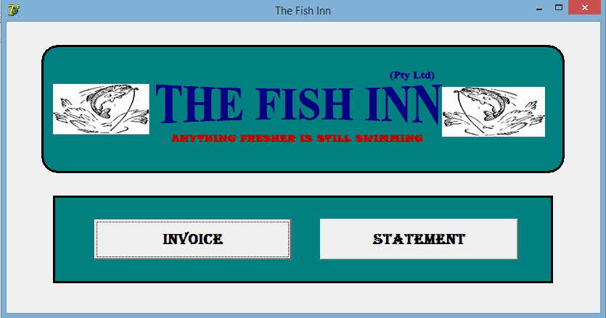

Developed by James Munnik

Signoffs
Phase | Teacher | Date | Signature
3) Technical documentation | Mrs. Niebuhr

Table of Contents
1. Summary 3
2. Externally Sourced Code / Libraries / Algorithms 3
3. Critical Algorithms 3
4. Advanced Techniques 3
5. Source Code 3
Class: ≪name of class≫ 3
Class: ≪name of class≫ 3
Class: ≪name of class≫ 4
Class: ≪name of class≫ 4
Class: ≪name of class≫ 4

1. Summary
This document contains the full code listing of the program. The following are isolated for specific consideration:
- Sourced code / Libraries / algorithms
- Critical algorithms
- Advanced techniques

2. Externally Sourced Code / Libraries / Algorithms
≪ This describes code included in the program not written / designed by the candidate. All researched advanced algorithms / component libraries MUST be declared here. This may not represent more than 10% of the program. You must reference where you got the code from‼ Also explain where and how you used it in your program.≫

3. Critical Algorithms
≪ Algorithms that have a significant effect on the performance of the program.
These may be represented as flowcharts / pseudocode AND Explanation of the critical algorithms≫

≪Heading one: Code to ……≫
≪Algorithm/FlowDiagram≫

≪Heading two: Code to ……≫
≪Algorithm/FlowDiagram≫

4. Advanced Techniques
≪ The candidate lists, AND explain, what they regard as the advanced techniques that they have applied / learnt in creating the code. This includes UI elements / algorithms / solutions that they have not been specifically taught in class. The more detailed this section is, the more likely you are to be awarded marks.≫

I used the following advanced techniques in my program:
- ≪Explain, e.g. I used … statements to …..≫

5. Source Code
≪A complete listing of the source code. Each class / unit file should have a heading that allows it to appear in the table of contents. NB: make sure that your working code complies with the marking rubric AND fulfills the criteria of the specifications document.≫

Class: ≪name of class≫
≪copy source code in≫

Class: ≪name of class≫
≪copy source code in≫

Class: ≪name of class≫
≪copy source code in≫

Class: ≪name of class≫
≪copy source code in≫

Class: ≪name of class≫
≪copy source code in≫

